HTML <form> Tag

The <form> tag is used to create an HTML form for user input.

The <form> element can contain one or more of the following form elements:

* <input>
* <textarea>
* <button>
* <select>
* <option>
* <optgroup>
* <fieldset>
* <label>

## Attributes

|  |  |  |
| --- | --- | --- |
| **Attribute** | **Value** | **Description** |
| accept | *file_type* | Not supported in HTML5. Specifies a comma-separated list of file types  that the server accepts (that can be submitted through the file upload) |
| accept-charset | *character_set* | Specifies the character encodings that are to be used for the form submission |
| action | *URL* | Specifies where to send the form-data when a form is submitted |
| autocomplete  [HTML 5] | on off | Specifies whether a form should have autocomplete on or off |
| enctype | application/x-www-form-urlencoded multipart/form-data text/plain | Specifies how the form-data should be encoded when submitting it to the server (only for method="post") |
| method | get post | Specifies the HTTP method to use when sending form-data |
| name | *text* | Specifies the name of a form |
| novalidate  [HTML 5] | novalidate | Specifies that the form should not be validated when submitted |
| target | _blank _self _parent _top | Specifies where to display the response that is received after submitting the form |

# HTML <input> Tag

The <input> tag specifies an input field where the user can enter data.

<input> elements are used within a <form> element to declare input controls that allow users to input data.

An input field can vary in many ways, depending on the **type** attribute.

**Note:**The <input> element is empty, it contains attributes only.

**Tip:** Use the <label> element to define labels for <input> elements.

## Attributes

|  |  |  |
| --- | --- | --- |
| **Attribute** | **Value** | **Description** |
| accept | file_extension audio/* video/* image/* *media_type* | Specifies the types of files that the server accepts (only for type="file") |
| align | left right top middle bottom | Not supported in HTML5. Specifies the alignment of an image input (only for type="image") |
| alt | *text* | Specifies an alternate text for images (only for type="image") |
| autocomplete  [HTML 5] | on off | Specifies whether an <input> element should have autocomplete enabled |
| autofocus  [HTML 5] | autofocus | Specifies that an <input> element should automatically get focus when the page loads |
| checked | checked | Specifies that an <input> element should be pre-selected when the page loads (for type="checkbox" or type="radio") |
| dirname  [HTML 5] | *inputname*.dir | Specifies that the text direction will be submitted |
| disabled | disabled | Specifies that an <input> element should be disabled |
| form  [HTML 5] | *form_id* | Specifies one or more forms the <input> element belongs to |
| formaction  [HTML 5] | *URL* | Specifies the URL of the file that will process the input control when the form is submitted (for type="submit" and type="image") |
| formenctype  [HTML 5] | application/x-www-form-urlencoded multipart/form-data text/plain | Specifies how the form-data should be encoded when submitting it to the server (for type="submit" and type="image") |
| formmethod  [HTML 5] | get post | Defines the HTTP method for sending data to the action URL (for type="submit" and type="image") |
| formnovalidate  [HTML 5] | formnovalidate | Defines that form elements should not be validated when submitted |
| formtarget  [HTML 5] | _blank _self _parent _top framename | Specifies where to display the response that is received after submitting the form (for type="submit" and type="image") |
| height  [HTML 5] | *pixels* | Specifies the height of an <input> element (only for type="image") |
| list  [HTML 5] | *datalist_id* | Refers to a <datalist> element that contains pre-defined options for an <input> element |
| max  [HTML 5] | *number date* | Specifies the maximum value for an <input> element |
| maxlength | *number* | Specifies the maximum number of characters allowed in an <input> element |
| min  [HTML 5] | *number date* | Specifies a minimum value for an <input> element |
| multiple  [HTML 5] | multiple | Specifies that a user can enter more than one value in an <input> element |
| name  [HTML 5] | *text* | Specifies the name of an <input> element |
| pattern  [HTML 5] | regexp | Specifies a regular expression that an <input> element's value is checked against |
| placeholder  [HTML 5] | *text* | Specifies a short hint that describes the expected value of an <input> element |
| readonly  [HTML 5] | readonly | Specifies that an input field is read-only |
| required  [HTML 5] | required | Specifies that an input field must be filled out before submitting the form |
| size | *number* | Specifies the width, in characters, of an <input> element |
| src | *URL* | Specifies the URL of the image to use as a submit button (only for type="image") |
| step  [HTML 5] | *number* | Specifies the legal number intervals for an input field |
| type | button checkbox color date  datetime  datetime-local  email  file hidden image month  number  password radio range  reset search submit tel text time  url week | Specifies the type <input> element to display |
| value | *text* | Specifies the value of an <input> element |
| width  [HTML 5] | *pixels* | Specifies the width of an <input> element (only for type="image") |

  First name: <input type="text" name="fname"><br>  
  Last name: <input type="text" name="lname"><br>  
  <input type="submit" value="Submit">

**Check Box Example:**

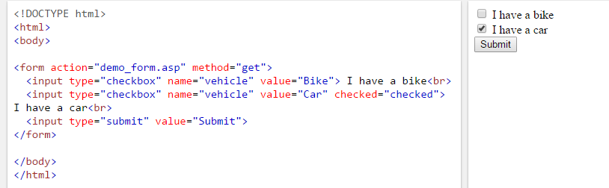

**Radio Button Example:**

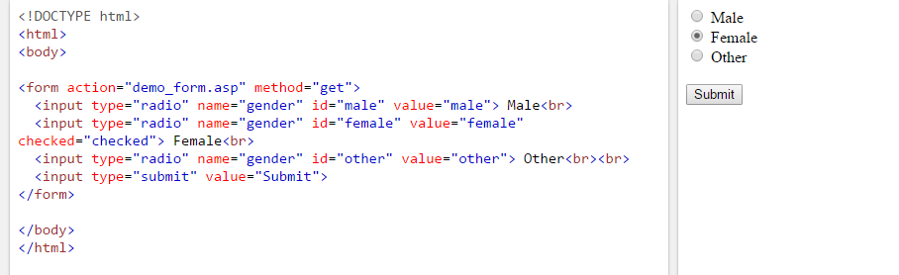

# HTML <textarea> Tag

The <textarea> tag defines a multi-line text input control.

A text area can hold an unlimited number of characters, and the text renders in a fixed-width font (usually Courier).

The size of a text area can be specified by the cols and rows attributes, or even better; through CSS' height and width properties.

## Attributes

HTML5 has added several new attributes.

|  |  |  |
| --- | --- | --- |
| **Attribute** | **Value** | **Description** |
| cols | *number* | Specifies the visible width of a text area |
| disabled | disabled | Specifies that a text area should be disabled |
| name | *text* | Specifies a name for a text area |
| readonly | readonly | Specifies that a text area should be read-only |
| rows | *number* | Specifies the visible number of lines in a text area |

<textarea rows="4" cols="50">  
In AWD class you will learn how to make a website. We offer tutorials in all web development technologies.   
</textarea>

# HTML <button> Tag

The <button> tag defines a clickable button.

Inside a <button> element you can put content, like text or images. This is the difference between this element and buttons created with the <input> element.

**Tip:** Always specify the type attribute for a <button> element. Different browsers use different default types for the <button> element.

**Note:** If you use the <button> element in an HTML form, different browsers may submit different values. Use <input> to create buttons in an HTML form.

## Attributes

HTML5 has new attributes: autofocus, form, formaction, formenctype, formmethod, formnovalidate, and formtarget.

|  |  |  |
| --- | --- | --- |
| **Attribute** | **Value** | **Description** |
| disabled | disabled | Specifies that a button should be disabled |
| name | *name* | Specifies a name for the button |
| type | button reset submit | Specifies the type of button |
| value | *text* | Specifies an initial value for the button |

<button type="button">Click Me!</button>

# HTML <select> Tag

The <select> element is used to create a drop-down list.

The <option> tags inside the <select> element define the available options in the list.

## Attributes

|  |  |  |
| --- | --- | --- |
| **Attribute** | **Value** | **Description** |
| autofocus  [HTML 5] | autofocus | Specifies that the drop-down list should automatically get focus when the page loads |
| disabled | disabled | Specifies that a drop-down list should be disabled |
| form  [HTML 5] | *form_id* | Defines one or more forms the select field belongs to |
| multiple | multiple | Specifies that multiple options can be selected at once |
| name | *name* | Defines a name for the drop-down list |
| required  [HTML 5] | required | Specifies that the user is required to select a value before submitting the form |
| size | *number* | Defines the number of visible options in a drop-down list |

<select>  
  <option value="volvo">Volvo</option>  
  <option value="saab">Saab</option>  
  <option value="mercedes">Mercedes</option>  
  <option value="audi">Audi</option>  
</select>

# HTML <option> Tag

The <option> tag defines an option in a select list.

<option> elements go inside a <select> or <datalist> element.

**Note:** The <option> tag can be used without any attributes, but you usually need the **value** attribute, which indicates what is sent to the server.

**Tip:** If you have a long list of options, you can group related options with the <optgroup> tag.

## Attributes

|  |  |  |
| --- | --- | --- |
| **Attribute** | **Value** | **Description** |
| disabled | disabled | Specifies that an option should be disabled |
| label | *text* | Specifies a shorter label for an option |
| selected | selected | Specifies that an option should be pre-selected when the page loads |
| value | *text* | Specifies the value to be sent to a server |

<select>  
  <option value="volvo">Volvo</option>  
  <option value="saab">Saab</option>  
  <option value="opel">Opel</option>  
  <option value="audi">Audi</option>  
</select>

# HTML <optgroup> Tag

The <optgroup> is used to group related options in a drop-down list.

If you have a long list of options, groups of related options are easier to handle for a user.

## Attributes

|  |  |  |
| --- | --- | --- |
| **Attribute** | **Value** | **Description** |
| disabled | disabled | Specifies that an option-group should be disabled |
| label | *text* | Specifies a label for an option-group |

<select>  
  <optgroup label="Swedish Cars">  
    <option value="volvo">Volvo</option>  
    <option value="saab">Saab</option>  
  </optgroup>  
  <optgroup label="German Cars">  
    <option value="mercedes">Mercedes</option>  
    <option value="audi">Audi</option>  
  </optgroup>  
</select>

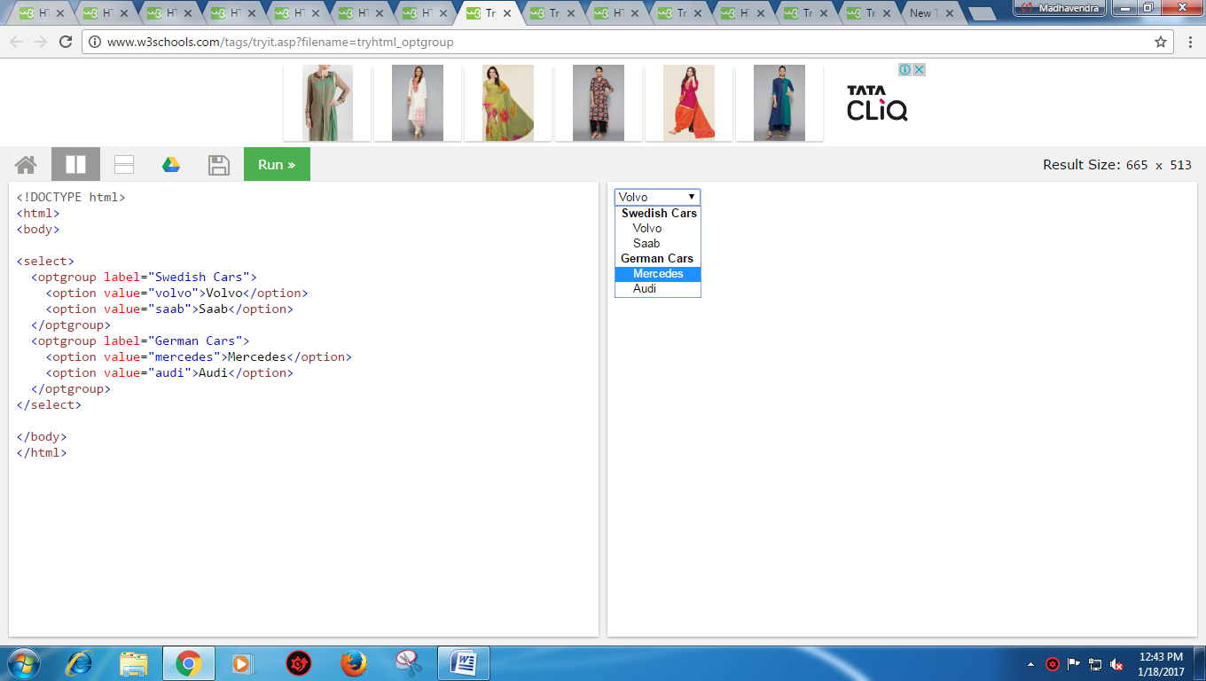

# HTML <fieldset> Tag

The <fieldset> tag is used to group related elements in a form.

The <fieldset> tag draws a box around the related elements.

**Tip:** The <legend> tag defines a caption for the <fieldset> element.

<form>  
  <fieldset>  
    <legend>Personalia:</legend>  
    Name: <input type="text"><br>  
    Email: <input type="text"><br>  
    Date of birth: <input type="text">  
  </fieldset>  
</form>

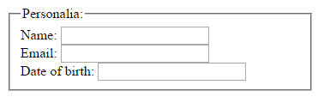

# HTML <label> Tag

The <label> tag defines a label for an <input> element.

The <label> element does not render as anything special for the user. However, it provides a usability improvement for mouse users, because if the user clicks on the text within the <label> element, it toggles the control.

The for attribute of the <label> tag should be equal to the id attribute of the related element to bind them together.

**Tip:** A label can be bound to an element either by using the "for" attribute, or by placing the element inside the <label> element.

## Attributes

|  |  |  |
| --- | --- | --- |
| **Attribute** | **Value** | **Description** |
| for | *element_id* | Specifies which form element a label is bound to |
| form  [HTML 5] | *form_id* | Specifies one or more forms the label belongs to |

<form action="demo_form.asp">  
  <label for="male">Male</label>  
  <input type="radio" name="gender" id="male" value="male"><br>  
  <label for="female">Female</label>  
  <input type="radio" name="gender" id="female" value="female"><br>  
  <label for="other">Other</label>  
  <input type="radio" name="gender" id="other" value="other"><br><br>  
  <input type="submit" value="Submit">  
</form>